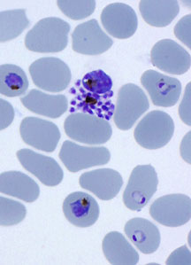
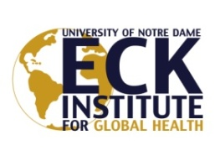PoST DoCTOral Position

Computational and Systems Biology of Pathogen Drug Resistance

The Ferdig lab (http://www3.nd.edu/~ferdilab/), in The Eck Institute for Global Health and the Department of Biological Sciences at the University of Notre Dame, is seeking a computational biologist with interest in network-based inference and large-scale data integration. The fellow will work both independently and as part of a collaborative team using whole-genome approaches to study drug targets and drug resistance evolution in the malaria parasite, Plasmodium falciparum.

A range of available projects includes: (1) Characterization and mining of transcript and regulatory networks of drug resistant parasites; (2) Systems genetics, using segregating parasite populations and mutant parasite libraries along with genome-scale data to connect genotypes to phenotypes; and (3) Integration of newly generated and existing public data to find drug targets, map chemical/cellular space not currently exploited by drugs and to predict effective drug combinations.

To align with these projects, the candidate should have a strong working knowledge of cellular mechanisms and biological pathways along with interest/expertise in one or more of the following:

- Regulation of gene expression; network analytical methods and data mining; accessing and integrating data resources; evolutionary genomics
- Mining of biological information, including transcript data from both microarrays and RNAseq; machine learning; skills in scripting languages such as Python, Perl, Matlab, or R.

The position is designed to ensure a strong training trajectory for a computational scientist aspiring to an independent research career. This includes a rich opportunity to interface with other quantitative/computational/evolutionary biologists across campus, including the Interdisciplinary Center for Network Science Applications (iCeNSA, http://www.icensa.com/), along with collaborators at other institutions. Salary will be at standard levels per NIH and institutional guidelines.

Submit a current C.V. and names of 3 references to Dr. Michael Ferdig, Professor, Department of Biological Sciences, University of Notre Dame, IN 46556-0369, ferdig.1@nd.edu
(574) 631-9973.

The Eck Institute for Global Health (EIGH, https://globalhealth.nd.edu/) is a university-wide institution that recognizes health as a fundamental human right and endeavors to promote research, training, and service to advance health standards for all people, especially people in low- and middle-income countries who are disproportionately impacted by preventable diseases.

The University of Notre Dame is an Affirmative Action/Equal Opportunity Employer. Women and minority candidates are encouraged to apply.

