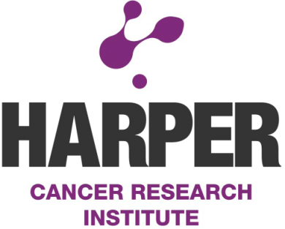

SEMINAR

Kathryn Packman, Ph.D
Scientific Director Oncology Collaborations
Janssen, Pharmaceutical Companies of Johnson & Johnson, Research and Development, LLC

“Advice for establishing a career in industry”

Dr. Packman received her Bachelor of Science degree in Biology from SUNY Geneseo and her Ph.D. in Cell and Molecular biology from the University of Notre Dame. After graduating from Notre Dame, Dr. Packman was a postdoc at the University for two years and went on to a successful career in industry. Currently, Dr. Packman is the Scientific Director Oncology Collaborations with Janssen, Pharmaceutical Companies of Johnson and Johnson. She has also taught as an Adjunct Professor for the University of Medicine and Dentistry of New Jersey for 10 years.

Tuesday, December 16, at 3:00
101 Harper Hall Multipurpose room

